PAPER: Four-hour thunderstorm nowcasting using a deep diffusion model for satellite data, arXiv:2404.10512 (Dec 2025)

Brief Description:
Overview:
- Introduces Deep Diffusion Model for Satellite data (DDMS), a new AI system designed for high-res thunderstorm (convective) nowcasting.
- Employs diffusion process to effectively simulated complicated spatiotemporal evolution patterns of convective clouds, achieving accurate forecasts of convective growth and dissipation over long lead times.
- Utilizes FengYun-4A geostationary satellite data, the model effectively simulates the complex life cycles of convective clouds, including their rapid growth and dissipation.
- Code is not open-source!! It is provided upon request.
Conclusion:
- This system achieves a four-hour lead time with remarkable accuracy, significantly surpassing traditional physical models, even the physics-based numerical weather prediction and existing deep learning methods.
- Rigorous testing indicates that DDMS provides planetary-scale coverage and maintains high resolution (SATCast is still developing this), making it a powerful tool for disaster emergency response.
- The study highlights the transformative potential of diffusion models in capturing the stochastic nature of severe atmospheric events.

Explanation:
A bit background:
- NWP methods are great for figuring out the weather a few days from now, but they kind of struggle with these super-fast local storms due to challenges in resolving rapidly evolving mesoscale or convective scale processes.
- PySteps models (simpler ones) looks at where a storm is moving and guess where it’s going to go next. They can’t tell if a storm is about to blow up. This is because of 2 reasons:
  - Estimated advection tendency is unable to capture the complexity of atmospheric variability (cloud formation and dissipation)
  - These methods are limited in their ability to leverage extensive historical data (when used with new data instead of their own trained data; generalising it) for modelling nonlinear spatiotemporal dynamics (rotation, dissipation, accumulation), since they estimate motion fields solely based on the recent observations.
- Classic CNN, RNN models would get blurry after 2 hours.
- Recent DL models such as DGMR, NowcastNet, etc, learn spatiotemporal evolution patterns from historical data in an end-to-end optimization manner. They can make effective predictions given observations.
- Despite the progress delivered by such existing AI approaches, Lead time coverage, spatial scale, and accuracy, especially in heavy rainfall closely related to convection, still remain challenging.
Neither of these approaches could reliably crack that crucial four-hour window. The essential reason is the lack of stable and reliable AI architectures designed to model the spatiotemporal evolution patterns of convective clouds, especially in the reasonable simulation of stochastic and uncertain motion patterns in the temporal evolution process of convective clouds.

Satellite monitoring is better than radar monitoring, achieving high spatiotemporal resolution convective monitoring (ref the paper for more)!!

Novel Perspective:
“the stochastic motion tendency of convective clouds can be regarded as a physical diffusion process, which can be effectively modeled with forward and backward procedures of diffusion models”
This is motivated by the recent work on “Score-based diffusion models” which compares different diffusion models for cloud modelling demonstrating their advantages in cloud growth and decay.
Based on their insights, they proposed a DDMS which utilizes satellite brightness temperature data and domain knowledge from experts, establishing a convective nowcasting system.

DDMS (High-Resolution Convective Nowcasting System):
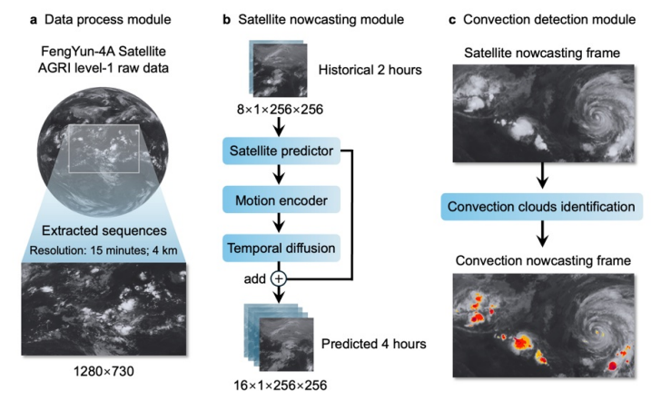
- Takes 4 years worth of images, taken every 15 minutes.
- Looks at the last two hours of satellite imagery and then generates a prediction of what the satellite will see for the next four hours.
- Scans those future images and flags the specific cloud shapes that signal a dangerous storm.
Training:
- The architecture features three primary components: a data process module, a satellite nowcasting module based on diffusion processes, and a convection detection module guided by expert knowledge.
  - In the Data process module, the satellite sequences are spatially cropped to 256x256 to reduce the computational demand of GPU in the training phase.
  - For the satellite nowcasting module, they model spatiotemporal patterns of convective clouds to predict the next 4-hour satellite sequences, based on historical 2-hour satellite sequences as input. The 2-hour history window provides sufficient temporal context for capturing the key developmental features of convective systems, which typically evolve on the scale of a few hours, while also keeping the computational cost manageable. (similar settings can be found in NowcastNet)
    - Satellite Predictor -> predicts satellite sequence with given past frames. Follows the RNN architecture, ConvGRU (effective spatiotemporal prediction baseline). It introduces deep residual mechanism and Skip connection manner to enhance spatiotemporal modelling ability. Has encoder and decoder parts, with ResNet blocks. Mean Absolute Error loss is used as Training loss.
    - Temporal Diffusion -> Model the temporal evolution dynamics of divergence between the predicted sequence and observation sequence. Diffusion network is trained based on the DDPM, which adopts a UNet model to predict the noise. Diffusion loss is used.
    - Motion Encoder -> Capture the long-term motion tendency (different levels of motion patternes) of the predicted sequence, to guide the denoising process of the temporal diffusion part.
    - Satellite predictor and Temporal diffusion part engage in a co-adversarial training method at the early stage to mitigate the spike in MAE loss at early stage of training of the satellite predictor causing the difference sequence to be hardly reconstructed by the temporal diffusion part.
    - By combining the predicted sequence by satellite predictor and the reconstructed difference sequence by temporal diffusion, we obtain the final prediction sequence.
  - For the convection detection module, they adopted DL methods and expert knowledge to achieve the automatic convective cloud recognition in the predicted satellite sequences.
    - Manually labelled a convective cloud dataset with the guidance of experts
    - And, trained a 2D-UNet to detect the convective cloud
- Training data: 2018 to 2021 (3 yrs)
- Testing data: 2022 and 2023 (1 yr)
- Validation set: 1% of training samples
- 8 GPUs, RTX A6000 GPUs (48GB memory)
- Two million training batches to converge (30 days)
- Adam Optimizer
- Exponential Moving Average (EMA) strategy with a Decay weight of 0.99 to update the parameters.
- Batch size: 8; Learning rate: 5e-5
- Dimensions of hidden states in the four-layer GRU are set to 64, 128, 192, and 256, respectively
- For the diffusion part, the forwarding step is set to 1000, while the denoising step is set to 200 with a DDIM sampling manner

Testing against established forecasting models:
Critical Success Index (CSI) Chart -
This is a standard way to grade a forecast, measuring the nowcasting accuracy of convective clouds.
- DDMS consistently outperforms traditional methods Persistency and PySTEPS (advection-based nowcasting approach). Compared with the baselines, DDMS maintains a clear superiority across all scales 4km, 8km, 16km, 48km.
- This advantage is evident at all evaluated scales and is generally more pronounced at shorter lead times, although the performance gap narrows at coarser scales (16- and 48-km) during the longer forecasting hours.
- NowcastNet (SOTA performance for 3-hour radar nowcasting) produces competitive results over a short period (from about 120 minutes to 210 minutes), particularly at the 4-km scale. but it performs considerably worse outside this interval.
- PredRNN-v2 (powerful spatiotemporal prediction model) performance declines at longer lead times and at coarse scales
- At 4 km scale, NowcastNet and PredRNN-v2 generally outperform Persistency and PySTEPS, which highlights the advantages of AI techniques in modelling high-resolution convective systems (i.e., the severe convective weather events, the model accurately predicts the convective growth, dissipation, and intensity of convective clouds.). In contrast, Persistency and PySTEPS exhibit relatively improved performance at the 48-km spatial scale, indicating that advection-based approaches can effectively capture large-scale cloud patterns
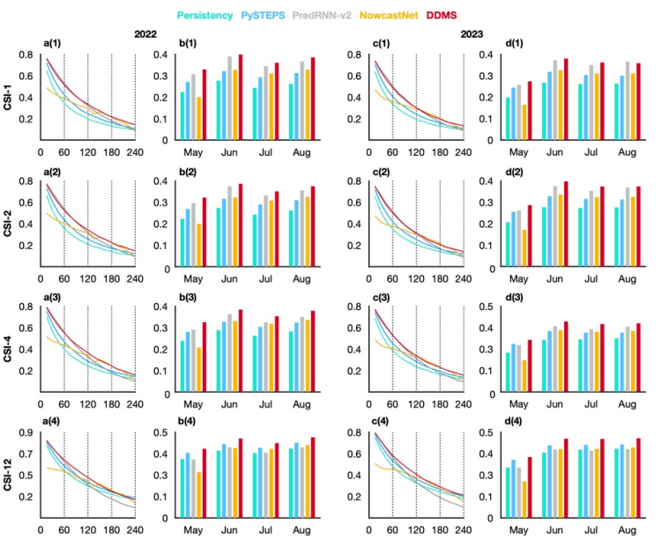
Other than CSI, they used:
- False alarm rate (FAR): denotes the false alarm rate, which is the lower the better.
- Probability of detection (POD): Represents the recall rate, which is the higher the better
- Heidke skill score (HSS): measures the improvSement over stochastic prediction, which is the higher the better
Test case (Convection event with an extreme rainstorm in South China, accompanied by Flood warnings):
- NowcastNet and PredRNN-v2 significantly overestimates the growth of the two convective cloud formations, which is actually disspating. In the last 2 hours, they fail to capture the disspation of the convective cloud.
- PySTEPS is unable to predict either the growth or dissipation of the convective clouds
- The three methods fail to deliver satisfactory 4-hour convection nowcasting, while the proposed DDMS produces much more accurate nowcasting results.

Future work:
- DDMS’s training cost is large due to the diffusion architecture, and it is important to explore more efficient diffusion models. (Latent?)
- Incorporating physical knowledge, like SATCast is a promising direction
- As a diffusion-based forecasting method, DDMS can produce ensemble predictions at inference, which provides a natural way to quantify forecasting uncertainty. With this, DDMS can do better future probabilistic convection nowcasting

